**Chocoholics Anonymous**



Use Case Specification Document

**0~~1~~ 6**

**Manage Provider**

**Version No. ~~1~~2.0**

**Project Document Revision History**

|  |  |  |  |
| --- | --- | --- | --- |
| **Version Number** | **Date** | **Revision Author** | **Description of Revision** |
| 1 | 06/11/2019 | Tejaswi Dasyam | Initial Version |
| 2 | 7/17/2019 | Maxx Achtman | Revised and updated version |

|  |
| --- |
| **Table of Contents** |

1. Introduction 4

2. Use Case Information 4

2.1. Actors 4

2.2. Use Case Interaction 4

3. Trigger 5

4. Pre-condition(s) 5

5. Post-condition(s) 5

6. Use Case Swimlane (Activity) Diagram 6

7. Main/Basic Flow(s) of Events (Happy Path) 7

8. Alternate/Exception Flow of Events 8

9. Assumptions/Business Rules including Non-Functional Requirements 9

10. Use Case Specification Review and Signoff 9

# Introduction

This use case highlights Chocoholics Anonymous Adding, updating and deleting process of ~~both Member and~~ Provider. During the Day time the Software allows the ChocAn operators to add a new ~~member, update existing member details, and delete an existing member from ChocAn. Similarly the software also manages~~ provider by adding, deleting, or updating ~~the addition, deletion and updating of a provider~~ from ChocAn. These details will be recorded in ChocAn Data Center System.

# Use Case Information

## Actors

An actor is someone or something (e.g. application system) outside the system or business that interacts with the application. For every Use Case, there must be at least one Main Actor and zero or more Secondary Actors. Actors should be a person, system, or time.

|  |  |  |
| --- | --- | --- |
| **Actor Name** | **Role** | **Description** |
| Operator | Main | Operator interacts with the ChocAn software during the day time and manages the member and provider records. |
| ~~Member~~ | ~~Secondary~~ | ~~Provides details to the operator for registration and updating, deleting the record.~~ |
| Provider | Secondary | Provides details to the operator for registration and updating, deleting the record. |
| System | Main | Registration, Updating and Deletion details will be stored in the ChocAn System (Data Center) |

## Use Case Interaction

**Predecessor:** None

**Successor:** Provide Service - (Use Case-05) - Only after the member is registered he can take service and provider also has to be registered in the system to provide service.

~~Member Payment-(Use Case-03) - Member can make monthly payments after he/she is registered with ChocAn.~~

# Trigger

No Triggers for this Use case. Operator will have to interact with the software and follow the required steps to add, delete or update ~~member’s or~~ provider’s records.

# Pre-condition(s)

For Adding a new ~~member or~~ provider, The Provider~~/Member~~ should give their details to the operator to complete the registration process.

Below are the preconditions required for Updating or deleting a ~~Member/~~Provider:-

* 1. To Update a ~~Member or~~ Provider record, The Member or provider should already be registered with ChocAn and registration details should be present in the ChocAn data Center.
  2. To Delete a ~~Member or~~ Provider record, The Member or provider should already be registered with ChocAn and the records should be present in the ChocAn data Center.

# Post-condition(s)

Possible outputs on completion are listed below:

* 1. After the New ~~Member/~~ Provider record is added by the operator,

**~~The Member~~** ~~–~~ **~~(i)~~** ~~Will get a member card and should be able to provide the card to the ChocAn to receive Health Services.~~ **~~(ii)~~** ~~Should be able to make monthly payment~~

**The Provider** – **(i)** should be able to view the services directory. **(ii)** provide health services to the members. **(iii)** swipe the members card to bill for the services. **(iv)** Sum the Weekly amount and request ChocAn for payment for the services they~~(provider)~~ provided.

* 1. After a ~~Member/~~ Provider is deleted from ChocAn, the corresponding member/provider records will be deleted from the data center.
  2. After an operator updates the ~~Member/~~Provider records then the updated details will be reflected in the ChocAn data center and whenever the operator access the ~~member/~~provider records after the update, software will show the updated details for the ~~member/~~provider.

# Use Case Swimlane (Activity) Diagram

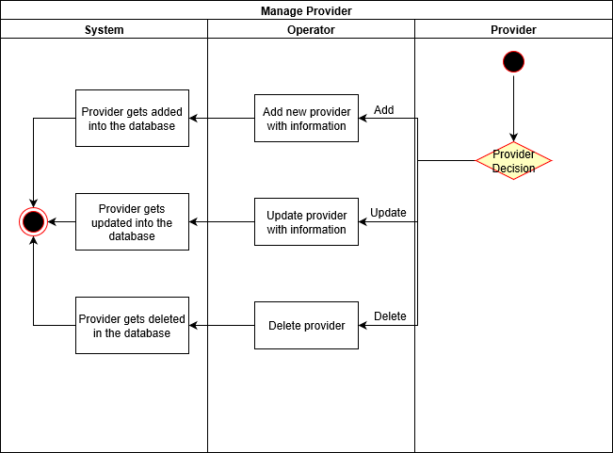

# Main/Basic Flow(s) of Events (Happy Path)

* 1. **~~Add Member:~~** 
     1. ~~Member will provide the required details like Name, Email address, Phone number, Address to the operator.~~
     2. ~~Operator will enter the member details on the terminal and submit.~~
     3. ~~Member will be registered and the details of the record will be saved in the ChocAn data center system.~~
  2. **~~Update Member:~~**
     1. ~~Member will provide the details of the fields that he/she wanted to be updated, like Name, Email address, Phone number, Address to the operator.~~
     2. ~~Operator will enter the updated member details on the terminal and submit.~~
     3. ~~Member details will be updated and will be saved to the ChocAn data center system.~~
  3. **~~Delete Member:~~**
     1. ~~Member will inform the operator that he no longer want to continue to receive the health services or the member had successfully completed the services and is no longer an addict to the chocolate and would like to discontinue.~~
     2. ~~Operator will enter the required data for the record termination and the reason for it, on the terminal and submit.~~
     3. ~~Member will be deleted from the ChocAn data Center system.~~
  4. **Add Provider:**
     1. Provider will give the required details like Name, Email address, ~~Phone number~~, Address to the operator.
     2. Operator will enter the provider details on the terminal and submit.
     3. Provider will be registered and the details of the record will be saved in the ChocAn data center system.
  5. **Update Provider:**
     1. Provider will provide the details of the fields that he/she wanted to be updated, like Name, Email address, ~~Phone number~~, Address to the operator.
     2. Operator will enter the updated provider details on the terminal and submit.
     3. Provider details will be updated and will be saved to the ChocAn data center system.
  6. **Delete Provider:**
     1. Provider will inform the operator that he no longer wants to continue to provide the health services to the members and would like to discontinue from ChocAn.
     2. Operator will enter the required data for the record termination and the reason for it, on the terminal and submit.
     3. Provider will be deleted from the ChocAn data Center system.

# Alternate/Exception Flow of Events

* 1. ~~Error message will be displayed if wrong details are entered during Member Registration / updating member records.~~
     1. ~~Member will provide the details of the fields like Name, Email address, Phone number, Address to the operator either for registration or for updating the record.~~
     2. ~~Operator will enter the Member details on the terminal and submit the form.~~
     3. ~~Error Message will be displayed if the details entered in the form are not in sync with the constraints of the data fields on the form.~~
  2. Error Message will be displayed if wrong details are entered during Provider Registration / updating Provider records.
     1. Provider will provide the details of the fields like Name, Email address, ~~Phone number~~, Address to the operator either for registration or for updating the record.
     2. Operator will enter the Provider details on the terminal and submit the form.
     3. Error Message will be displayed if the details entered in the form are not in sync with the constraints of the data fields on the form.

# Assumptions/Business Rules including Non-Functional Requirements

Assumption: (i) Provider ~~/ Member~~ provides the required details to the operator for registration and updating the records.

(ii) For updating or deleting the records the ~~member/~~provider should be an existing ~~member/~~provider of ChocAn

(iii) For Record Deletion, ~~Member and~~ Provider ~~had~~ has to approach and confirm that they no longer want to be a part of ChocAn. Then the operator will take necessary action to delete the record.

# Use Case Specification Review and Signoff

|  |  |  |  |
| --- | --- | --- | --- |
| Review and Signoff of the Use Case Specification | | | |
| **Name** | **Project Team Role** | **Signature** | **Date** |
| Tejaswi Dasyam | Team Member | tejaswi | 06/11/2019 |
| Vaishali Jain | Team Member | vaishalijain | 06/11/2019 |
| Khushmeet Kaur | Team Member | khushmeetkaur | 06/11/2019 |
| Mohanapriya Kottan Rajaraman | Team Member | Mohanapriya | 06/11/2019 |
| Kopal Shinde | Team Lead | kopal | 06/11/2019 |